Code Breaker

User Guide

|  |  |  |  |
| --- | --- | --- | --- |
| Change Version | Change | Signature | Date |
| 1.0 | Initial | Charlie Morrison | 26/12/22 |
|  |  |  |  |
|  |  |  |  |
|  |  |  |  |
|  |  |  |  |

Contents

2 Document Information 3

2.1 Classification 3

2.2 Purpose 3

2.3 Target Audience 3

3 Procedure 4

3.1 Main Menu 4

3.2 Game 4

3.3 Settings 5

3.3.1 Guess Limiter 5

3.3.2 Character Bounds 5

3.3.3 Hint Limiter 5

# Document Information

## Classification

The classification of this document is Unclassified – Uncontrolled if Printed. No security measures are implemented.

## Purpose

The purpose of this document is to guide all users of the program codebreaker.py, which is contained within this package. It will go into the basic usages of this game and how to use it, inclusive of the parental settings, which are blocked by a secured password.

## Target Audience

The target audience of this document is users of the program codebreaker.py and those who plan on improving their gameplay by amending the settings.

# Procedure

## Diagram Description automatically generated with medium confidenceMain Menu

The main menu displays three (3) options. Option one (1) specifies to play. In order to select this option, type the number “1” (without quotes) and press the Enter or Return key. This also applies to selecting option two (2), settings. Option three will close the application.

## Game

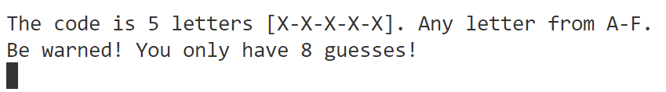The game is a code breaker. Guess 5 letters and the game will let you know how close or far you are from the code which it has automatically generated. Upon beginning the game, it will tell you the rules. The default rules are 8 guesses and letters between A and F. This is A, B, C, D, E, and F.

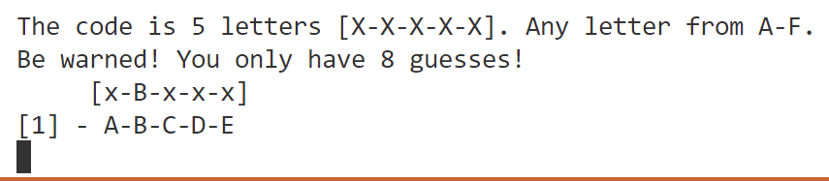Guess the code by putting in the five (5) letters. Such as: “ABCDE” (excluding quotes) This input is not case sensitive, you can input upper or lower case letters.

The screen will now look different from the previous, there are now two additional lines. The screen has reminded you of the rules (in case you forget).

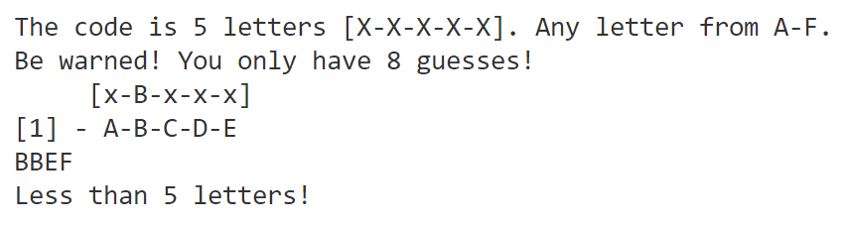It has also listed the current hint [x-B-x-x-x], or the letters which you have gotten correct. The letters which are incorrect are marked with an x. Therefore, you are aware that in this instance, the second letter is correct, as the letter B.

The final line which has been displayed is the guess counter. In this scenario, the game states that your first guess was ABCDE. The counter will go up until you have reached the guess limit, which is stated on the second line (“You only have 8 guesses”)

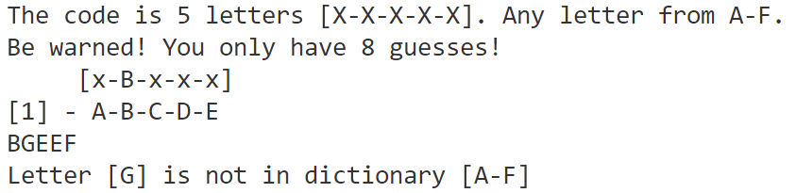If you have put in less than 5 letters, the game will let you know. If you enter more than 5 letters, the game will limit to the first 5 letters which you have entered. The game will also know whether you enter a letter which is not within the specified range, in this case, A-F.

## Settings

When selecting settings, it may feel as if nothing has happened. This is the parental control feature. This is to prevent children from entering the settings and turning the game into an unplayable state on accident without knowing how to reverse it. You will be required to enter the passphrase “1337” (without quotes) as soon as you enter the value 2.

In figure 1, the password feature has been enabled and you cannot enter until you have entered the passphrase “1337”, as displayed in figure 2. After entering the passphrase, figure 3 will appear with the full settings displayed.

### Guess Limiter

The guess limiter is a simple feature to make the game quicker and slightly harder. It limits the amounts of incorrect guesses until failure.

### Character Bounds

The character bounds should only be used by someone with great confidence. The only options are a small range A-F, and a large range of the entire alphabet A-Z (excluding lower case letters). It is recommended to not change the guess limiter off 8 if playing with the entire alphabet.

### Hint Limiter

This feature is not yet enabled for this version of the game. It will be in a later stage.